Ghana Smart Service Operations Optimizer

M1 — Input-Output and Problem Specification
UG Campus Service Hub — DCIT 204/308 Joint DSA Project
This document defines the five major operations of the system: expected inputs, outputs, assumptions, constraints, pseudocode, and a flowchart for each, per Section 5 (M1) of the brief.

1. Schedule Next Request
Answers problem statement question (i): which service request should be handled next under FIFO, urgency, and priority-based rules.

Inputs / Outputs / Assumptions
- Input: current dispatch rule (FIFO | URGENCY | PRIORITY), current queue/heap of pending service requests
- Output: the selected ServiceRequest, removed from its structure and marked in-progress
- Assumptions: every request has a valid urgency 1-5; the structure chosen (Queue/Deque/BinaryHeap) matches the active rule
- Constraints: O(1) for FIFO dequeue; O(log n) for priority-queue extract-max
- Edge cases: empty queue (no request to dispatch); all requests tied on urgency (fall back to FIFO order)

Pseudocode
function scheduleNext(rule, structure):
if structure.isEmpty():
return null // edge case: nothing to dispatch
if rule == FIFO:
request = structure.dequeue()
else if rule == URGENCY or rule == PRIORITY:
request = structure.extractMax() // BinaryHeap keyed on urgency
else if rule == URGENT_INSERT:
request = structure.removeFront() // Deque, urgent jobs pushed to front
assignToResource(request)
logAuditEvent("DISPATCH", request.requestId)
return request

Flowchart
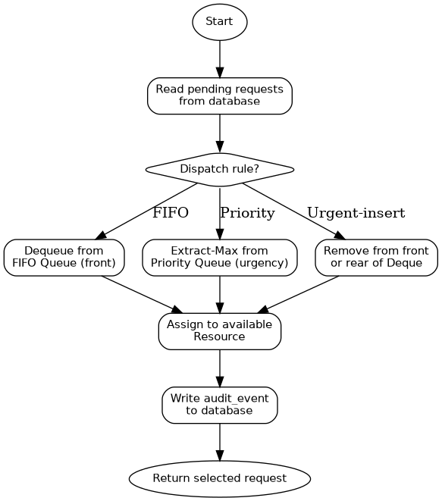

2. Find Fastest Route
Answers problem statement question (ii): fastest route from one local location to another under weighted-road conditions.

Inputs / Outputs / Assumptions
- Input: source locationId, destination locationId, CampusGraph (adjacency list, weights = distance + route penalty on poor-condition roads)
- Output: ordered path (list of locationIds) and total weighted distance
- Assumptions: all edge weights are non-negative (required for Dijkstra correctness); graph is connected for the queried pair, or an 'unreachable' result is returned
- Constraints: O((V+E) log V) using a binary heap as the priority queue
- Edge cases: source == destination (distance 0); destination unreachable (return infinity/no path)

Pseudocode
function findRoute(source, destination, graph):
if source not in graph or destination not in graph:
return ERROR
dist[all nodes] = infinity
dist[source] = 0
prev[all nodes] = null
pq = new BinaryHeap(minBy dist)
pq.insert(source)
while not pq.isEmpty():
u = pq.extractMin()
if u == destination: break
for (v, weight) in graph.neighbours(u):
if dist[u] + weight < dist[v]:
dist[v] = dist[u] + weight
prev[v] = u
pq.insert(v)
if dist[destination] == infinity:
return UNREACHABLE
return reconstructPath(prev, destination), dist[destination]

Flowchart
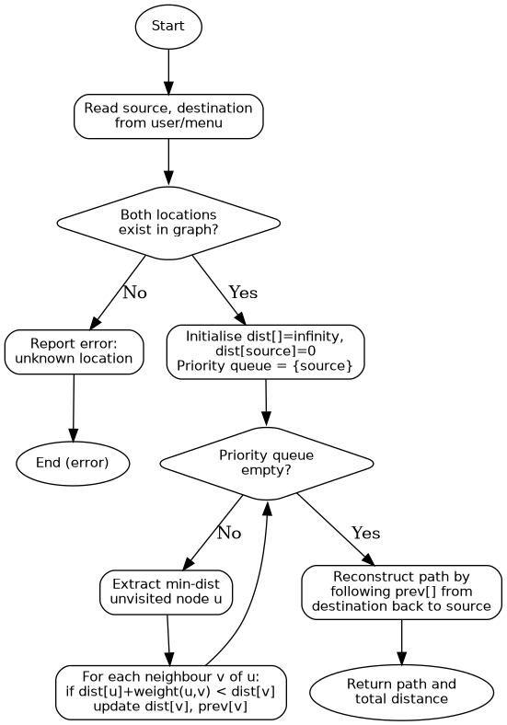

3. Check Reachability
Answers problem statement question (iii): which locations are reachable from the current dispatch point.

Inputs / Outputs / Assumptions
- Input: dispatch point locationId, CampusGraph
- Output: list of all locationIds reachable from the dispatch point
- Assumptions: graph may be disconnected — unreachable nodes are simply excluded from the result, not an error
- Constraints: O(V+E) using BFS with a custom Queue
- Edge cases: dispatch point has no neighbours (result = itself only); disconnected graph

Pseudocode
function checkReachability(start, graph):
visited = new Set(), for all false
queue = new Queue()
queue.enqueue(start)
visited.add(start)
reachable = []
while not queue.isEmpty():
u = queue.dequeue()
reachable.add(u)
for v in graph.neighbours(u):
if v not in visited:
visited.add(v)
queue.enqueue(v)
return reachable

Flowchart
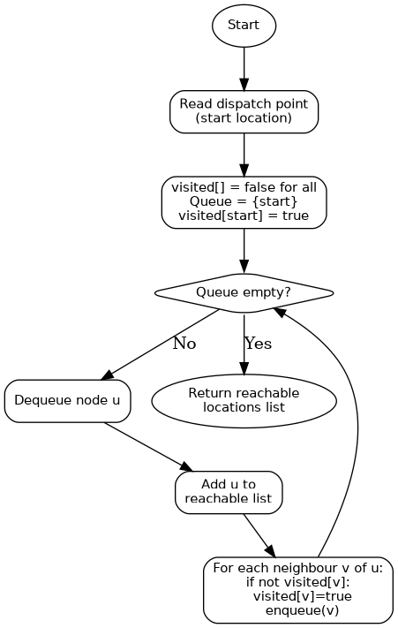

4. Optimise Requests Under Budget
Answers problem statement question (iv): which subset of requests can be selected under a budget/capacity/time constraint.

Inputs / Outputs / Assumptions
- Input: list of pending requests (value = urgency, weight = estimated service hours), budget (52 hours, derived from team index numbers)
- Output: selected subset of requests maximising total urgency value without exceeding the budget
- Assumptions: each request is indivisible (0/1 knapsack, not fractional); weight and value are non-negative integers
- Constraints: O(n x budget) time and space for the DP table
- Edge cases: a single request whose weight exceeds the entire budget (excluded); budget = 0 (empty selection)

Pseudocode
function optimiseUnderBudget(requests, budget):
n = requests.length
dp = new Table[n+1][budget+1], all 0
for i in 1..n:
for c in 0..budget:
dp[i][c] = dp[i-1][c]
if requests[i].weight <= c:
dp[i][c] = max(dp[i][c],
requests[i].value + dp[i-1][c - requests[i].weight])
selected = []
c = budget
for i in n..1:
if dp[i][c] != dp[i-1][c]:
selected.add(requests[i])
c = c - requests[i].weight
return selected, dp[n][budget]

Flowchart
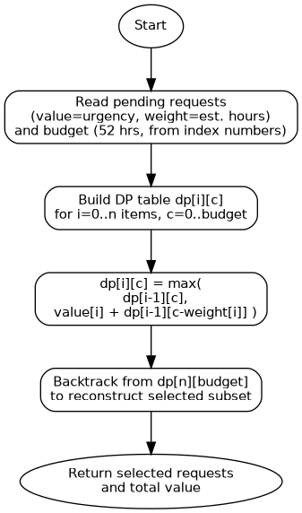

5. Persist and Reload Data
Answers problem statement question (vi): how the system stores records permanently and reloads them for later analysis.

Inputs / Outputs / Assumptions
- Input: none (runs automatically on program start/exit) or an explicit save/reload menu command
- Output: an in-memory system state (custom data structures) that mirrors the database, and a database that survives program restarts
- Assumptions: schema.sql has already been applied at least once; CSV files are only used to seed an empty database, not as the system of record
- Constraints: all writes during the running session go through the database (write-through), not just to memory
- Edge cases: database file missing on first run (create it); CSV seed data partially malformed (validate and skip bad rows with a logged warning)

Pseudocode
function startup():
connection = openDatabase("campus.db")
if not connection.hasTables():
connection.executeScript("schema.sql")
if connection.isEmpty("locations"):
importCsv("locations.csv") into connection
importCsv("roads.csv") into connection
importCsv("service_requests.csv") into connection
importCsv("resources.csv") into connection
locations = connection.queryAll("locations")
roads = connection.queryAll("roads")
requests = connection.queryAll("service_requests")
reloadIntoStructures(locations, roads, requests) // build graph, queues, hash table
return connection

Flowchart
